Emergency Management: Plans That Match the Actual Threat
Wed, Sep 16, 6:00 PM EDT

TL;DR — Emergency plans start from a risk assessment and have to fit real geographic, structural, and operational context. The harder point most plans get wrong: evacuation, shelter-in-place, and lockdown are three different doctrines for three different kinds of threat, and using the wrong one is actively dangerous. Accounting for every person at a muster point is the step that actually matters, drills only work if they're not fully announced, and none of this is the same document as keeping the business running afterward: that's a separate plan with a separate job.
Emergency planning goes wrong when it's generic, so it starts with a risk assessment: what actually threatens this site, given its geography, its building, and how it operates? A coastal office plans for hurricanes; a Midwest one for tornadoes; a facility in fire country for wildfire. NIST's own contingency-planning guidance (SP 800-34) treats this life-safety layer as its own document, the Occupant Emergency Plan, deliberately "developed at the facility level, specific to the geographic location and structural design of the building." A template lifted from somewhere else will confidently tell your people to do the wrong thing at the worst possible moment.

Three different verbs, not one
The distinction that actually matters is that "emergency response" isn't one action. It's at least three, and they're not interchangeable. Evacuation means leaving the structure entirely, by a known route, to a point outside: the right call when the danger is inside the building or the building itself (fire, a gas leak, structural damage). Shelter-in-place means the opposite: staying inside and sealing off from a hazard you can't outrun outside, such as severe weather, or, per NIST's own framing of the same plan type, a chemical release. Lockdown is neither: it means securing an interior space against a threat that is a person, inside or near the building, by locking doors, killing lights, staying silent, and waiting for law enforcement rather than moving through open corridors where the threat might be. Confusing these is not a paperwork problem. Evacuating during a lockdown can walk people directly into a threat, and sheltering in place during a fire can trap them. The doctrine has to match the threat, which is exactly why the plan starts with a risk assessment instead of a template.
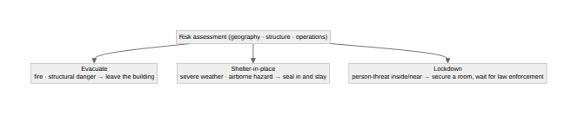

Fire, and the accounting step that actually matters
Fire is the universal case, and its plan is a clear sequence: notify the fire department, evacuate the building, and reassemble at a designated muster point. The step that actually matters is the last one: accounting for every person, not just watching a crowd gather. OSHA's emergency action plan rule (29 CFR 1910.38) requires, as a minimum element, "procedures to account for all employees after evacuation," and that's the honest bar: a headcount that "looks about right" isn't accounting for anyone. Real accountability means a roster, a floor warden with a list, checked against who badged in that day, because the failure mode is always the same person: someone in the restroom during the alarm, or a contractor onsite who was never on any list to begin with. You don't actually know everyone is safe until the count matches a real source of truth.
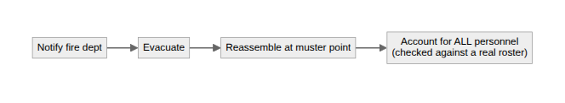

Weather, and the rule that overrides everything
Weather emergencies are where regional tailoring shows most, because the correct response inverts by hazard. For a tornado, you go in and down: a basement, or an interior windowless room, and building experts, not guesswork, should identify where that actually is in your structure. Winter weather and wildfire call for entirely different playbooks. Cutting across all of them is one standing rule: employees have to know the office-closure procedure, and no deadline is worth someone driving through conditions that aren't safe to travel in.

Workplace violence needs its own lockdown plan
Workplace violence is the hardest one to plan for and exactly the reason to plan it calmly, in advance, rather than improvise under real pressure. It needs a genuine lockdown plan: where people find safe refuge, how they secure the room, and the procedure for reaching law enforcement. Just as important, the all-clear has to come from authorities, not from people guessing the danger has passed.

A different plan altogether: staying safe vs. staying in business
It's worth naming a distinction plans often blur: keeping people safe in the first minutes of an emergency is not the same job as keeping the business running afterward. NIST draws this line explicitly: the life-safety plan is executed as "a first response to the incident," separate from the Business Continuity Plan, which "focuses on sustaining an organization's mission/business processes during and after a disruption" (payroll, customer service, the work itself). The first is minutes long, run by whoever's in the building, and done once everyone is accounted for. The second is hours or days long, run by process owners who may not even be onsite, and picks up exactly where the first one leaves off. Bundling them into a single document is a common mistake, because the audiences, timelines, and definitions of "done" are genuinely different.

Drills only work unannounced
An evacuation plan nobody has practiced becomes a confused crowd in a stairwell, but an announced drill only proves people can walk calmly to a spot they already knew about, at a time they were told to expect it. That's rehearsing compliance, not readiness. It doesn't test whether the alarm is audible in the loud corner of the warehouse, whether the "clear" exit route now has a pallet blocking it, or whether the warden's roster still matches who's actually in the building. OSHA's rule requires that people understand their role in the plan, not a specific drill cadence, but an untested plan is exactly how an organization finds out, mid-emergency, that it doesn't work. The pattern across every emergency type is the same: decide what people should do before the crisis, match it to the real threat, and test it in a way that can actually fail, so that when the moment comes, the plan carries people instead of panic.
Written by Scott S. — Contact: scott@scottschlangen.com — scottslab.io — https://scottslab.io/posts/emergency-management-planning

